GitHub

Definition
# Source: ScreenShots Source: Provided by: [Persons Table -> ID Column: 1, Name_En Column: Motasem Essam] -> Tool: [Lightshot Program] -> From [Site: https://github.com/] on [4/21/2026]
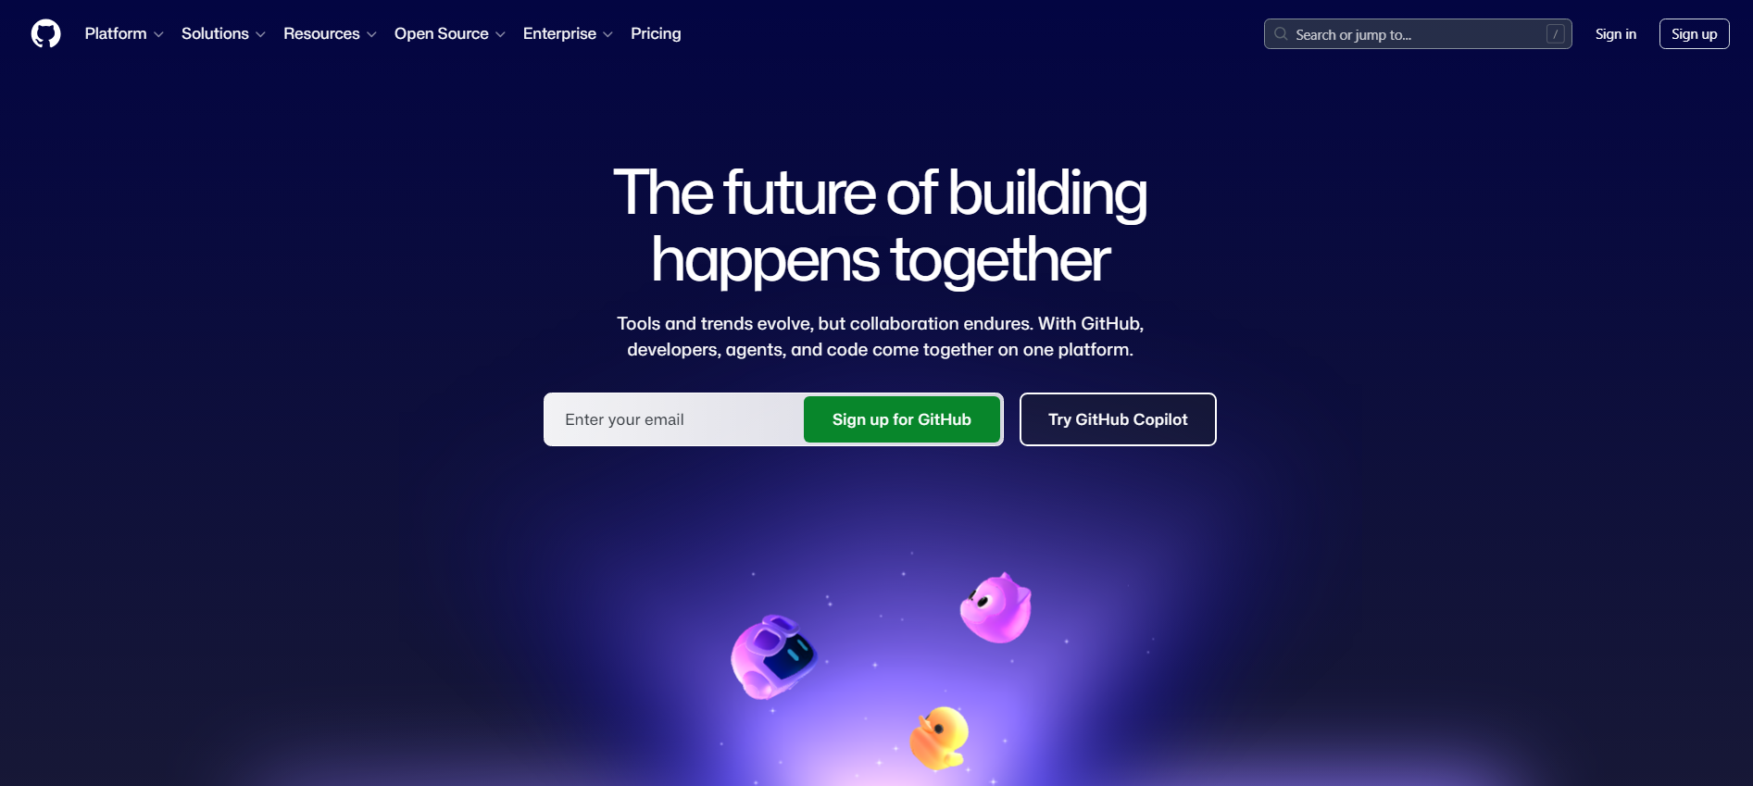
# Source: AI Source: Provided by: [Data Path: Persons Table -> ID Column: 1, Name_En Column: Motasem Essam] -> From: [ChatGPT] on [4/21/2026]
GitHub is mainly built around Git, a version control system. It helps people:
- Store code in repositories (repos)
- Track changes over time (called commits)
- Work together using branches and pull requests
- Fix bugs and improve software collaboratively

Key Features

1. Repositories
# Source: AI Source: Provided by: [Data Path: Persons Table -> ID Column: 1, Name_En Column: Motasem Essam] -> From: [ChatGPT] on [2/15/2026]
A repository is like a project folder containing:
- Code
- Documentation
- Project history

2. Version Control (Git)
# Source: AI Source: Provided by: [Data Path: Persons Table -> ID Column: 1, Name_En Column: Motasem Essam] -> From: [ChatGPT] on [2/15/2026]
GitHub keeps a full history of changes:
- Who changed what
- When it changed
- Why it changed
This makes it easy to undo mistakes.

3. Collaboration Tools
# Source: AI Source: Provided by: [Data Path: Persons Table -> ID Column: 1, Name_En Column: Motasem Essam] -> From: [ChatGPT] on [2/15/2026]
- Pull Requests → propose and review changes
- Issues → track bugs and tasks
- Discussions → team communication

4. Open Source Projects
# Source: AI Source: Provided by: [Data Path: Persons Table -> ID Column: 1, Name_En Column: Motasem Essam] -> From: [ChatGPT] on [2/15/2026]
Many projects are public, allowing anyone to:
- View code
- Suggest improvements
- Contribute fixes
Examples include large tools like Linux-related projects, web frameworks, and libraries.

Who uses GitHub?
# Source: AI Source: Provided by: [Data Path: Persons Table -> ID Column: 1, Name_En Column: Motasem Essam] -> From: [ChatGPT] on [2/15/2026]
- Software developers
- Data scientists
- Companies (small startups to big tech firms)
- Students learning programming

Simple way to think about it
# Source: AI Source: Provided by: [Data Path: Persons Table -> ID Column: 1, Name_En Column: Motasem Essam] -> From: [ChatGPT] on [2/15/2026]
GitHub is like a:
Google Drive for code + a collaboration system + version history tracker

Why it matters
# Source: AI Source: Provided by: [Data Path: Persons Table -> ID Column: 1, Name_En Column: Motasem Essam] -> From: [ChatGPT] on [2/15/2026]
- Prevents losing work
- Makes teamwork easier
- Helps build large software projects safely
- Powers most modern software development

